Digital Marketing Analysis

Nowadays, a lot of data is received whenever a digital marketing campaign is created (impressions, clicks, users, bounce rate, etc.). However, many companies still do not know how much to spend on Digital Marketing, the marketing channels to focus on, and the amount of conversions they should expect depending on a specific budget. Therefore, if we could analyze all different marketing campaigns in order to know which ones are the ones that perform the best and how many conversions we could expect, companies could improve their decision making.

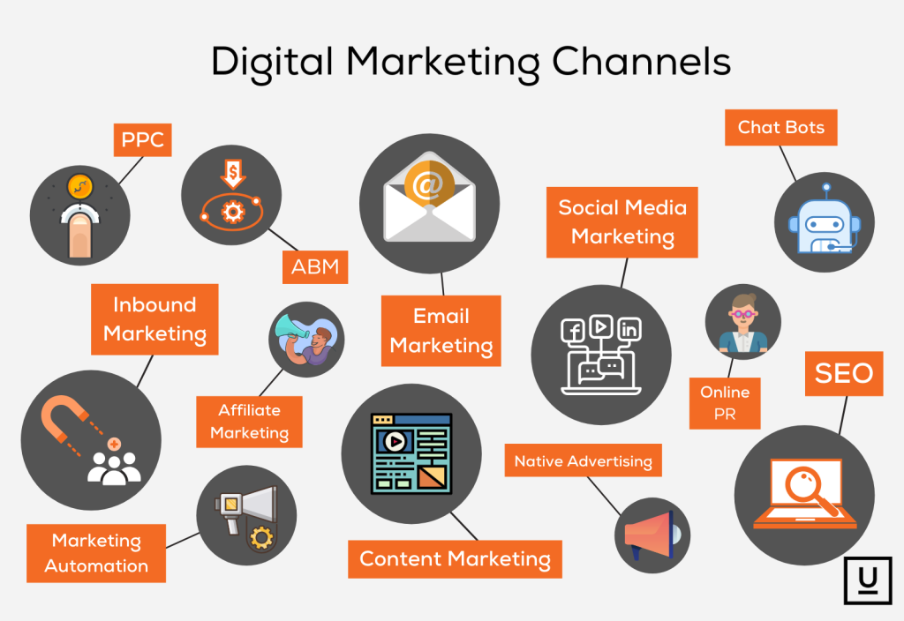

# Industry Problem: Digital Marketing Expectations

People and companies do not know what to expect from their digital marketing campaigns because they do not do the proper analysis using the information given from previous campaigns. The main problem companies are facing is how much to spend on Digital Ads and how many conversions that investment will attract.

## How Much to Spend on Digital Marketing?

Depending on the size, the budget for marketing campaigns vary. It does not matter if there is a big or small budget, it is hard to decide on a specific number because it could be seen as a waste of money and if it is not done correctly, this could be true. Therefore, an analysis from previous campaigns could be done to have an idea of how much is worth it to start investing on a specific marketing channel and how much this investment will come back in sales.

## How Many Conversions (or Sales) Should a Company Expect?

Once a budget is decided, it is hard to have an idea and even harder to know how many sales or conversions will bring a specific investment in a campaign. Therefore, sometimes Marketing could be seen as a blind bet. However, doing the right analysis and having the right amount of data, these decisions could stop being a blind bet and start being seen as statistics. These statistics could be enough to start making the right choices and start predicting or having the right sales expectations for a specific campaign.

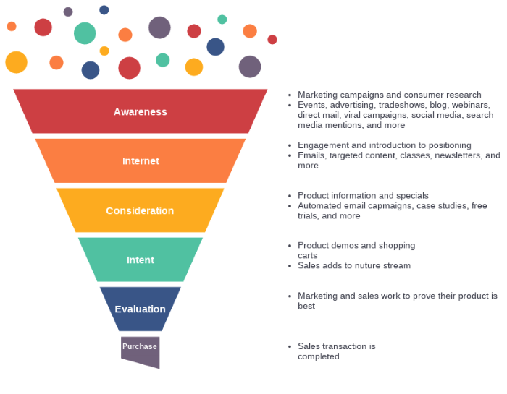

# Why is This Important to a Business?

All companies should invest in marketing in order to let their audience (or market) know they exist. Digital Marketing, different from traditional marketing (mainly TV and Radio) provides all kinds of data that could be analyzed in order to have an idea on what to expect and make better decisions. If a company could know how many conversions they could expect for every amount in dollars spent in marketing, it could be easier for them to make better budget allocations, choose the right marketing channels to find the right customers for them and increase overall sales for the business which would lead to growth.

## Budget Allocation

Structured companies have budget allocations on different departments in order to cover their expenses and investments. If the marketing department of a business can predict the right investment in Digital Marketing Campaigns that will bring a specific amount in sales, then the business can prepare better for the future and provide the right budget for the marketing department for the business to grow enough for the other departments to handle the growth.

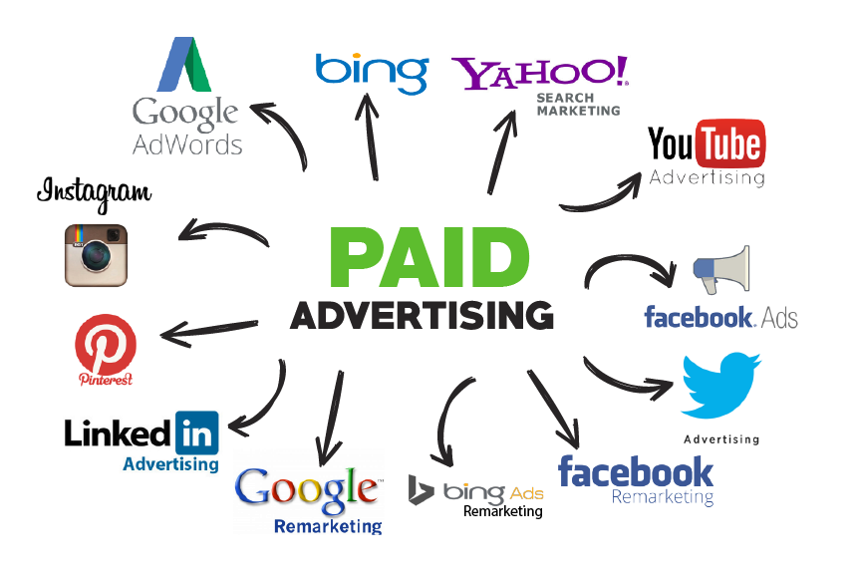

## Choose Better Marketing Channels

It is important to know how much to spend in marketing and the conversions it will bring because this will bring better decision making. Nowadays, there are many Marketing Channels to find the right customer. Therefore, it is hard to pick and choose which one is the right one. These decisions should be done by using data instead of feelings. If there is enough data for different digital marketing channels, there should be a way to get all that data per channel, analyze it, understand it, and make the right decisions on where to use the marketing budgets focusing on campaign performance rather than a campaign being prettier or nicer.

## Increase Overall Conversions (Sales)

All businesses want to grow and sell more. That is why this is the focus of this analysis. The idea is to be able to predict using different variables obtained from Digital Ads to understand which are the ones that affect the most on the final result (conversions) in order to have an idea of how many conversions a company could get depending on their budget.



# Methods & Results

For this analysis, I used different methods like Support-Vector Machines (SVM), Stepwise Models, and K-Nearest neighbour (KNN). Even though I only used a publicly available database from a company doing Facebook Ads, the idea is to use this analysis to gather data from different campaigns and channels in order to improve prediction and compare channels. When I used the Stepwise Model, all of them showed that from the data used, the best variables to be used were Impressions and Spent to predict Total Conversions. Therefore, these were the variables I used for the next model which was KNN. This last model used was the model that provided the best accuracy of 0.7081 or 71%. This means that this model would be correct more or less 7 out of 10 times which would be a good indicator to at least have an idea on how much conversions to expect depending on a specific budget. On the other hand, this accuracy may improve we had a bigger database.

